**Limited Production Message Review Instructions All in One**

Updated on 2023-07-26

Ying Shen, Jheri Godfrey, and Katherine Luce

**Contents**

1. Check the LPM in MVPS
2. Request Data load into NNAD and the Completeness Report
3. Review Completeness Report
4. **Instructions of Limited Production Message Check in MVPS**

When you receive an email from CSELS asking us to review jurisdiction LPM, you start the following steps.

**Step1**: Go here and open the SAS program: ***Check MVPS for Messages LPM.SAS***

**Step2**: Update the Jurisdiction FIPS code and the mvps_datetime_updated (this time should be informed by CSELS), then run the program.



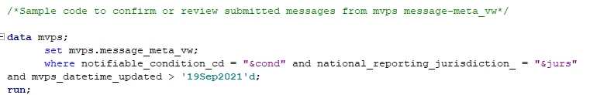

**Step3**: Review the output in the Result Viewer and make sure the numbers of messages with current_record_flag=”Y” matches what jurisdictions/CSELS tell us. If the number doesn’t match what jurisdictions tell us, confirm with CSELS and move forward. Then save the data to the Limited Production Folder here.

For example, …\FL\COVID-19\Limited Production Messages

Done!

Next, we will go ahead and request data load and the Completeness Report for LPM. Go to the next page.

**2 Instructions of LPM Data Load and Completeness Report**

**Step0:** Append GENV2 and COVID-19 Implementation Spreadsheets

1. Open the jurisdiction’s most recent GenV2 and COVID-19 Implementation Spreadsheet **Review Sheets** that are saved here
2. Open the GENV2 IS and select and copy all values starting at row #4
3. Open the COVID-19 IS and paste the selected values after the last entry
4. Save as new document here and re-name like example below:

***NE COVID-19 Implementation Spreadsheet NCIRD Review_Appended_3-25-21***

**Step1**: Send an email to Sang/Akesh and ask them to load the LPM data from MVPS_ONB into NNAD Staging and run the Completeness Report. Remember to attach:

1. the LPM list that you saved to the jurisdiction LPM folder, (For example, …\FL\COVID-19\Limited Production Messages)
2. The appended Implementation Spreadsheet Review Sheet saved in the jurisdiction’s folder here (this IS Review Sheet is needed for running the Completeness Report)

**Step2**: After Informatics send an email back with the Completeness Report, make sure the denominator of the Completeness Report matches what jurisdiction/CSELS tell us.

**Step3**: Forward the Completeness Report to Sandy, Pam and Ying.

Done!

**3.Review Completeness report**

**Step0**: Open the completeness report found here

The report shows the percent completeness of each data element for which the jurisdiction indicated “**Yes, will be collected** “in the jurisdiction’s Implementation Spreadsheet.

Data completeness is indicated in the **percent complete** column of the report:

**Green:** Data present for 66.67% or more of the cases

**Yellow:** Data present for 33.34% to 66.66% of the cases

**Red:** Data present for 33.33% or fewer of the cases.

**Gray:**  Data elements that will not be collected are shaded out in gray

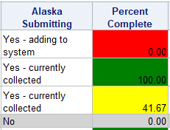

**Step1**: Review the overall completeness

1. Make note if more than 50% of all COVID 19 data elements show zero completeness.
2. If grayed out data elements show red text (as seen below), check the jurisdiction’s implementation spreadsheet here and identify if the jurisdiction intended to send information in those data elements.

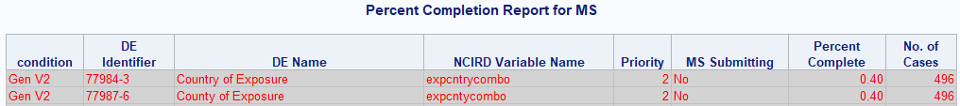

1. A singular period notes that the data element is not in the analysis.



**Step2**: Review priority 1 data elements

1. Filter the priority column to “1”. Make note of COVID 19 priority one data elements that show zero completeness
2. Review completeness of vaccine repeating group data elements below:

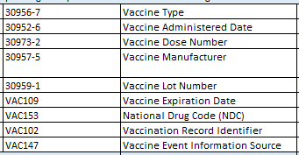



Make note if vaccine **administered type, vaccine manufacturer, vaccine administered date** and **first positive specimen date** show zero completeness.

**Step3**: Using a sample email template found here, draft your findings to the Team for review.